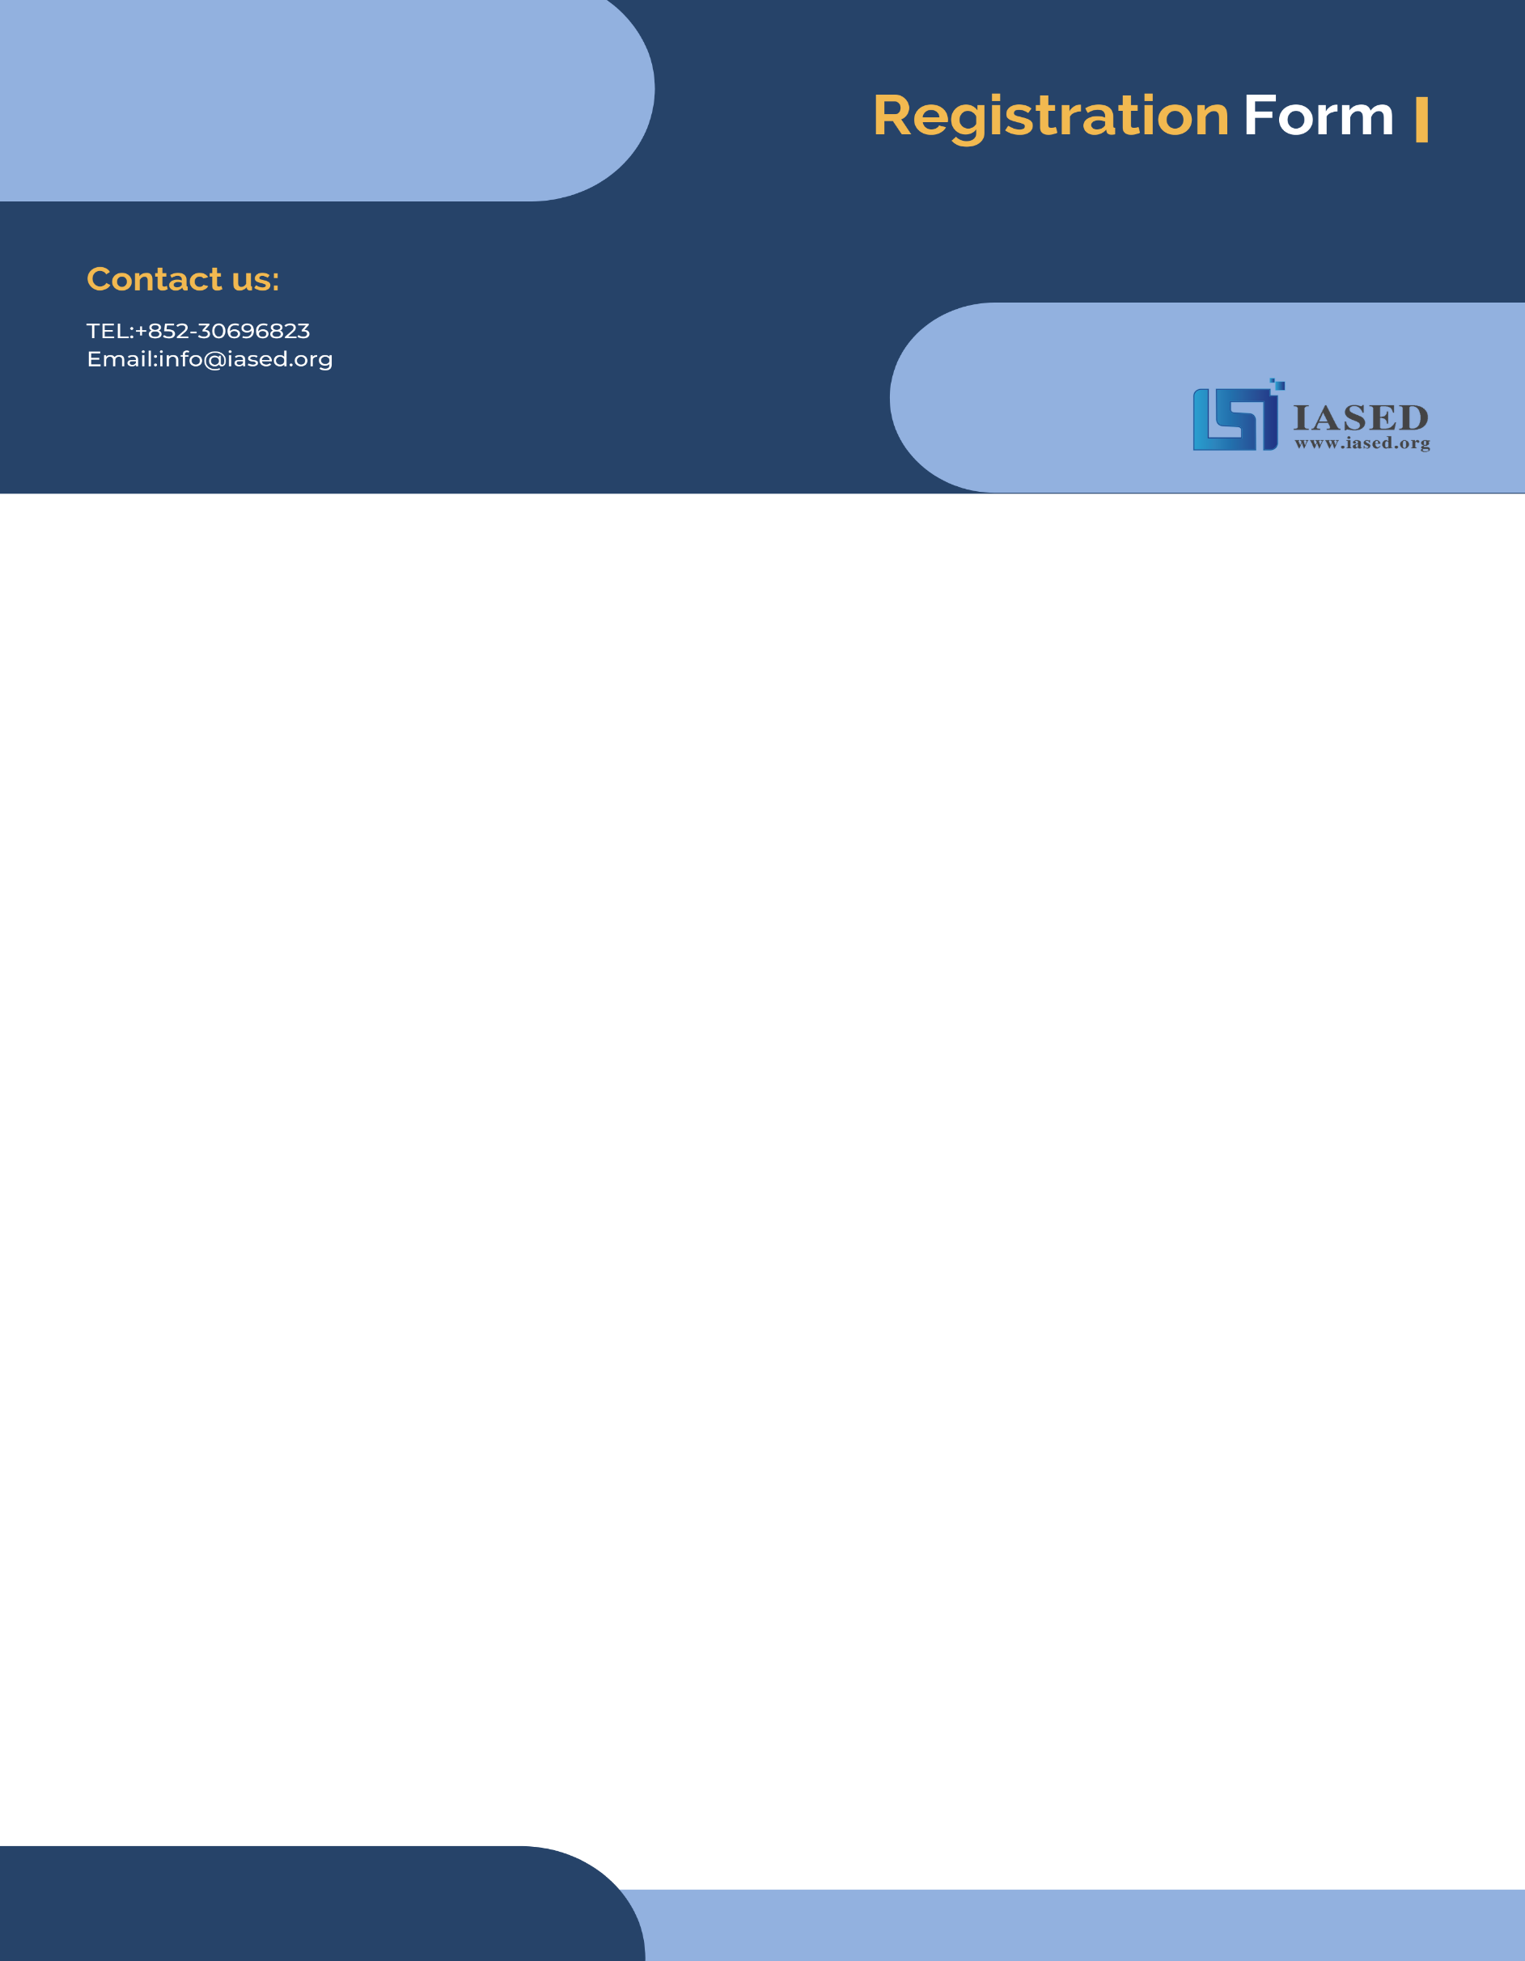
NOTE: Make sure to submit all required documents: 1. final paper (doc & pdf files), 2. completed registration form, 3. Payment Voucher to inquiry@meamt.org (Mail Subject: Paper ID + Registration).
2024 International Conference on Material Engineering and Advanced Manufacturing Technology(MEAMT 2024)
July 19-21 | www.meamt.org
- ATTENDEE INFORMATION
*Full Name: | 1-inch-Photo here
*Position√: Prof. Assoc. Prof. Asst. Prof. Dr. Mr. Ms.
*Affiliation & Nation:
*Email:
*Mobile Phone:
*Alternative Liaison (Name & Mobile):
Address& Zip Code:
Catering (On-site conference on July 20th): Lunch Dinner
Special dietary√: Diabetic Vegetarian Halal food Other (please specify: )
Special requirements:

- PAPER INFORMATION
*Paper ID: *Paper Pages: *Extra Page(>5 pages):
*Paper Title:
*Authors:
*Will you be present at the on-site conference? Yes No
*Presentation Type√: Oral (15 min) Poster (5 min) Video (15 min)
*Participation Certificate√: Softcopy Hardcopy I do not need the certificate
Student ID No. (student only):
IASED Member No. (member only):
* Receipt Issued to:

- PRICE INFORMATION
Onsite Conference
Category |  | Early Birds  (due by April 21, 2024) | Regular  Registration | On-site  Registration  (July 21, 2024) | Your  Choice
Full Paper | Regular Author | 500USD | 550USD | 600USD
 | Student\  Committee | 450USD | 500USD | 550USD
 | IASED Member | 470USD | 520USD | 570USD
Abstract | Regular Presenter | 400USD | 450USD | 500USD
 | Student\Committee Presenter | 350USD | 400USD | 450USD
 | IASED Member Presenter | 380USD | 430USD | 480USD
Others
Additional Page | 70USD
Extra Paper Upload | 300USD
Listener\Co-Author | 250USD
Extra Conference Proceeding | 65USD
Extra Banquet Ticket | 50USD
City Tour\Social Networking Event (Optional) | TBD
Notice
*If the paper exceeds 5 pages, the additional pages will be charged. The recommended general length limit is no less than 4 pages.
*All papers will be published online.
*For "No shows", registration fee is nonrefundable.
*Shall the conference is delayed or prevented (directly or indirectly) by the reasons of natural disasters, war, strike(s), epidemic or any other events which could not be controlled, the organizing committee shall be under no liabilities. The organizing committee reserves the right to change the conference date, venue or form of the conference (online or on-site)
*Cancellation policy: Applicant should send the refund/cancellation requests to inquiry@meamt.org. (The Cancellation policy are available in the official website of the MEAMT 2024: www.meamt.org)
*Our payment system will not charge any extra fee, but the credit card payment may incur currency exchange charge which is charged by payers' bank, it should be borne by payers.
*One day program fee covers: Attend meeting sessions on July 20th. Only do a presentation (without publishing any papers) + coffee breaks, lunch and dinner (onsite conference) + conference kits (onsite conference).
*Full registration fee for conference covers (Onsite Author only): publication fee + meeting sessions on July 20th + 2 coffee breaks, 1lunch, 1dinner on July 20th + conference kits.

- PAYMENT INFORMATION
Online Payment linkage
http://meeting.yizhifubj.com/web/main.action?meetingId=351
E-mail: | Confirmation Number:
* VISA /Master cards are recommended payment methods. We will not charge any handling fees, please calculate the amount before you finish the payment.  * Please fill your E-mail address used for payment and Confirmation Number you received after paying.  * As the system will intercept the email address for multiple payments, it is recommended to use different email for each payment  *Please make sure the conference organizer, IASED’s logo is always appear on the page until you click “Pay”. Then you will be directed to payment page. | 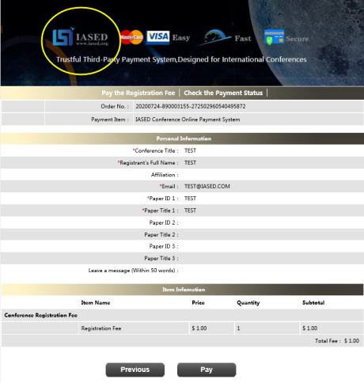
- IASED MEMBER APPLICATION
Join IASED now to quality for member registration rates. Please compile and return the Membership Form along with your CV to membership@iased.org. Your application will be processed in 5 working days.
- OTHER
Finally, we suggest you write down a biographical sketch here, for use of making introductions by Session Chair before your presentation gets started.
20-120 Words(1-3 lines)
Contact us at IASED LinkedIn:
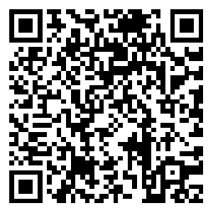
IASED LinkedIn
MEAMT 2024 Organizing Committee

